5/8/2024

**Fatima Suleiman Chukwuma Okafor Uyi Omere Oluwaseun Oyeranti**

**Weather Data Visualisation.**

Developing a web-based interactive visualisation using JavaScript and the D3 library

**Contents**

1. Product Backlog 1

2. Sprint Planning 3

2.1 Sprint 1 (March 18 - March 31) 3

2.2 Sprint 2 (April 1 - April 21) 4

2.3 Sprint 3 (April 22 - April 29) 4

2.4 Sprint 4 (April 30 - May 5) 4

3. Daily Stand-Up 4

3.1 Stand up 1: March 31, 2024 5

3.2 Stand up 2: April 11, 2024 6

3.3 Stand up 3: April 22, 2024 8

3.4 Stand up 4: April 29, 2024 9

3.5 Sprint 4: May 7, 2024 11

4. Sprint Retrospective 12

4.1 Sprint 1 Retrospective 12

4.2 Sprint 2 Retrospective 12

4.3 Sprint 3 Retrospective 12

4.4 Sprint 4 Retrospective 12

5. Conclusion 12

# **Product Backlog**

On February 5, 2024, a group of four students was formed to work on the project. The initial task was to identify a suitable dataset for creating a web-based interactive visualisation using JavaScript and the D3 library.

**Initial Dataset Exploration**

Car Price Dataset:

The group initially selected a car price dataset but later dropped it because the columns in the dataset were not unique enough for each member to tell a coherent story that aligned with the project brief. As seen in Figure 1, a conversation on Teams highlighted this challenge voiced by one of the group members.

Figure 1: Teams Conversation Highlighting Dataset Challenge

World Billionaires Dataset:

The group then considered a dataset about world billionaires that was sent to the group chat created on Teams by February 26, 2024, as shown in Figure 2.

Figure 2: World Billionaires Dataset Discussion

The group decided to clean the dataset and create draft visualisations that could be shown to the lab tutor by March 1, 2024, as seen in Figures 3 and 4.

Figure 3: Conversation showing timeline set to making a draft presentation to the Lab Tutor.

|  |  |
| --- | --- |
|  |  |

Figure 4: Some draft visualisation presented to the Lab Tutor.

However, this was also found unsuitable after consultation with the lab tutor on 4th March 2024, as seen in the conclusion presented in Figure 5.

Figure 5: Conclusion on World Billionaires Dataset

Weather Dataset:

Finally, the group settled on a weather dataset, which met the requirements of the brief and provided clear direction for the visualisation for each team member. This dataset was presented to the lab tutor on 11th March and the lab tutor was satisfied with the data and the general theme of the group wanted to present on using the data.

Figure 6: Conversation on the weather dataset.

The group settled on the weather dataset on March 18, 2024, leaving roughly seven weeks until the final submission deadline of May 8, 2024. The group aimed to complete the project two weeks before the deadline, leaving five weeks for development.

|  |  |  |  |  |
| --- | --- | --- | --- | --- |
| **ID** | **User Story** | **Priority** | **Estimate (Weeks)** | **Notes** |
| 1 | As a user, I want to view the average annual temperature trends of different cities in England. | High | 5 | Assigned to Uyi. |
| 2 | As a user, I want to see the geographical distribution of temperature using a world map. | High | 5 | Assigned to Chukwuma. |
| 3 | As a user, I want to compare temperature variations across cities in the United Kingdom using a stacked column chart. | High | 5 | Assigned to Fatima. |
| 4 | As a user, I want to explore correlations between temperature and population using a scatter plot. | High | 5 | Assigned to Seun |

Table 1: planned user stories for each team member

# **Sprint Planning**

## **2.1 Sprint 1 (March 18 - March 31)**

Objective: Clean and prepare the weather dataset and create initial visualisation prototypes for each chart.

|  |  |  |  |
| --- | --- | --- | --- |
| **Task ID** | **Task Description** | **Assigned To** | **Status** |
| 1 | Clean and prepare the weather dataset | All members | Completed |
| 2 | Prototype line chart for annual temperature trends. | Uyi | Completed |
| 3 | Prototype geographical temperature distribution | Chukwuma | Completed |
| 4 | Prototype stacked column chart for regional temps | Fatima | Completed |
| 5 | Prototype scatter plot for temperature correlation | Seun | Completed |

## **2.2 Sprint 2 (April 1 - April 21)**

Objective: Develop interactive visualisations using D3.js for each chart and start integrating into a web application.

|  |  |  |  |
| --- | --- | --- | --- |
| **Task ID** | **Task Description** | **Assigned To** | **Status** |
| 6 | Develop interactive line chart for annual trends | Uyi | Completed |
| 7 | Develop an interactive geographical temperature map. | Chukwuma | Completed |
| 8 | Develop interactive stacked column chart for regions | Fatima | Completed |
| 9 | Develop interactive scatter plot for correlation | Seun | Completed |

## **2.3 Sprint 3 (April 22 - April 29)**

Objective: Finalise the web application and test for usability.

|  |  |  |  |
| --- | --- | --- | --- |
| **Task ID** | **Task Description** | **Assigned To** | **Status** |
| 10 | Integrate all charts into the web application | All members | Completed |
| 11 | Test and refine the web application | All members | Completed |

## **2.4 Sprint 4 (April 30 - May 5)**

Objective: Finalise the project and prepare for the presentation.

|  |  |  |  |
| --- | --- | --- | --- |
| **Task ID** | **Task Description** | **Assigned To** | **Status** |
| 12 | Develop the landing page | Uyi, Chukwuma | Completed |
| 13 | Develop PowerPoint presentation | All members | Completed |
| 14 | Review and edit PowerPoint presentation | Uyi, Fatima | Completed |
| 15 | Prepare for the presentation | All members | Completed |

# **Daily Stand-Up**

Daily stand-ups are brief meetings, usually lasting around 15 minutes, where each team member provides updates on their tasks. For this project, stand-up meetings were conducted at the end of each sprint. However, given the importance of Sprint 2 and its longer duration, two stand-up meetings were held during that sprint. The format for each stand-up is as follows:

Stand-Up Format

Each team member answers the following questions:

What did I do concerning the just completed Sprint?

What will I work on for the next sprint?

Did I face any blockers during the just completed sprint and what I did to navigate it?

## **3.1 Stand up 1: March 31, 2024**

This meeting was done using Google Meet for convenience as it was on a weekend. The screenshot taken during the meeting is presented in Figure 7 below as evidence. The summary presented by each person is as follows:

Uyi:

Just completed: Cleaned and prepared the weather dataset. Developed a prototype line chart for annual temperature trends using Excel.

Next: Develop interactive line chart for annual temperature trends using D3.js.

Blockers: Cleaning the dataset took longer than expected.

Chukwuma:

Just completed: Prepared the weather dataset.

Next: Try to develop the prototype geographical temperature distribution using Power BI before developing it using D3.js.

Blockers: Cleaning the dataset was time-consuming due to formatting issues in the downloaded data.

Fatima:

Just completed: Cleaned and processed the weather dataset. Developed a prototype stacked column chart for regional temperatures using Excel.

Next: Develop interactive stacked column chart for regional temperatures using D3.js.

Blockers: The dataset required extensive preprocessing as I needed to do annual computations.

Seun:

Just completed: Cleaned and prepared the weather dataset. Developed a prototype scatter plot for temperature correlation using Excel.

Next: Develop interactive scatter plot for temperature correlation using D3.js.

Blockers: Preparing the dataset took longer than anticipated due to complex computations needed to calculate the average for each decade.

Figure 7: Screenshot of Sprint 1 Stand-Up Meeting.

## **3.2 Stand up 2: April 11, 2024**

Given the success of the first stand-up using a virtual platform, the team agreed to do this meeting using Google Meet again. The evidence of this meeting is presented in Figure 8. However, during the meeting, the team agreed that due to the technical nature of this stage of the project, it would be better for the next stand-up to be physical so that they could have time to look through each other's code. The summary of the stand-up is presented as follows:

Uyi:

Just completed: Started developing the interactive line chart for annual temperature trends using D3.js.

Next: Continue working on the interactive line chart.

Blockers: Faced issues aligning the x-axis with the data points, still troubleshooting this issue.

Chukwuma:

Just completed: Started developing the interactive geographical temperature map using D3.js.

Next: Continue working on the interactive geographical temperature map.

Blockers: Encountered difficulties overlaying multiple data points on the map, still trying to resolve this.

Fatima:

Just completed: Started developing the interactive stacked column chart for regional temperatures using D3.js.

Next: Continue working on the interactive stacked column chart.

Blockers: Had trouble implementing the interactive features, still trying to figure this out.

Seun:

Just completed: Started developing the interactive scatter plot for temperature correlation using D3.js.

Next: Continue working on the interactive scatter plot.

Blockers: Faced issues with the scale of the y-axis, still working on it.

Figure 8: Screenshot of Sprint 2 Stand-Up Meeting

## **3.3 Stand up 3: April 22, 2024**

The team decided to hold this stand-up meeting in person for better collaboration, as agreed during the previous stand-up (evidence is presented in Figure 9). This allowed them to review each other's code and assist in troubleshooting any issues. The summary of the stand-up is presented as follows:

Uyi:

Just completed: Continued working on the interactive line chart for annual temperature trends using D3.js.

Next: Finalise the interactive line chart and integrate it into the web application.

Blockers: Resolved issues aligning the x-axis with the data points, but now facing challenges with tooltips.

Chukwuma:

Just completed: Continued working on the interactive geographical temperature map using D3.js.

Next: Finalise the interactive geographical temperature map and integrate it into the web application.

Blockers: Resolved difficulties overlaying multiple data points on the map, but now facing challenges with zoom functionality.

Fatima:

Just completed: Continued working on the interactive stacked column chart for regional temperatures using D3.js.

Next: Finalise the interactive stacked column chart and integrate it into the web application.

Blockers: Resolved issues with interactivity, but now facing challenges with data labels.

Seun:

Just completed: Continued working on the interactive scatter plot for temperature correlation using D3.js.

Next: Finalise the interactive scatter plot and integrate it into the web application.

Blockers: Resolved issues with the scale of the y-axis, but now facing challenges with hover interactions.

Figure 9: In-Person Stand-Up Meeting

## **3.4 Stand up 4: April 29, 2024**

The team held this stand-up meeting in person, just as they did for the second stand-up in Sprint 2 as presented in Figure 10. This allowed for better collaboration as we integrated the interactive charts into the web application and tested the overall usability of the product. The summary of the stand-up is presented as follows:

Uyi:

Just completed: Finalised the interactive line chart for annual temperature trends and integrated it into the web application.

Next: Test the usability of the line chart and refine it.

Blockers: Had issues with tooltips overlapping but resolved this by adjusting the placement.

Chukwuma:

Just completed: Finalised the interactive geographical temperature map and integrated it into the web application.

Next: Test the usability of the geographical temperature map and refine it.

Blockers: Faced challenges with zoom functionality but resolved this by limiting the zoom levels.

Fatima:

Just completed: Finalised the interactive stacked column chart for regional temperatures and integrated it into the web application.

Next: Test the usability of the stacked column chart and refine it.

Blockers: Encountered issues with data labels but resolved this.

Seun:

Just completed: Finalised the interactive scatter plot for temperature correlation and integrated it into the web application.

Next: Test the usability of the scatter plot and refine it.

Blockers: Had challenges with hover interactions but resolved this by tweaking the hover effects.

Figure 10: In-Person Stand-Up Meeting for Sprint 3

## **3.5 Sprint 4: May 7, 2024**

The team held this stand-up meeting online, as presented in Figure 11. The focus was on finalising the project and preparing for the presentation, as the submission deadline was imminent. The conclusion was that the team would have a draft presentation on May 12, 2024. The summary of the stand-up is presented as follows:

Uyi:

Just completed: Finalised the landing page and prepared the PowerPoint presentation.

Chukwuma:

Just completed: Finalised the landing page and prepared the PowerPoint presentation.

Fatima:

Just completed: Finalised the PowerPoint presentation and reviewed it.

Seun:

Just completed: Finalised the PowerPoint presentation and reviewed it.

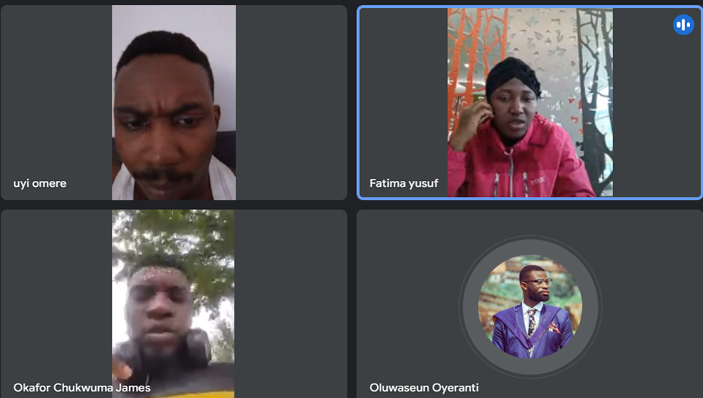

Figure 11: Online Stand-Up Meeting for Sprint 4

# **4. Sprint Retrospective**

A Sprint Retrospective focuses on reflecting upon the last sprint to identify what went well, what did not, and what the team should do differently going forward.

## **4.1 Sprint 1 Retrospective**

What went well: The team successfully identified a suitable dataset and created initial prototypes.

What did not go well: Cleaning the dataset took longer than expected.

Action items: Let's be more hands-on with this project as the deadline will come in no time if we are not careful.

## **4.2 Sprint 2 Retrospective**

What went well: The team successfully developed interactive visualisations using D3.js.

What did not go well: Aligning the charts and implementing interactivity proved challenging.

Action items: Allocate time for chart refinement and interactivity testing.

## **4.3 Sprint 3 Retrospective**

What went well: The team integrated the web application successfully and conducted usability testing.

What did not go well: Some usability issues persisted, and alignment issues needed fixing.

Action items: Focus on refining alignment and preparing the presentation.

## **4.4 Sprint 4 Retrospective**

What went well: The team finalised the web application and prepared the presentation.

What did not go well: The team felt rushed towards the end.

Action items: Start final preparations earlier in future projects.

# **5. Conclusion**

The project aimed to create a web-based interactive visualisation using JavaScript and the D3 library, with each team member producing one chart aligned with a coherent theme.

**Accomplishments**

* The team successfully identified and cleaned a suitable weather dataset, developed interactive visualisations, integrated the charts into a web application, and prepared a comprehensive presentation.
* Each team member contributed effectively to their assigned chart, and the team worked collaboratively to align the charts into a cohesive story.

**Challenges**

* The team faced challenges in finding the suitable data at the start of the project.
* Developing the interactive charts using D3.js presented technical difficulties, particularly with aligning elements and implementing interactivity.
* Time management became crucial, especially towards the end of the project, as the team worked to finalise the application and prepare the presentation.

**Lessons Learned**

* Effective communication and collaboration are key to successful project outcomes, especially when working with complex datasets and technical requirements.
* Early testing and frequent stand-ups helped identify and address issues promptly, leading to a more polished final product.
* Allocating ample time for data preparation and chart refinement is crucial when dealing with complex visualisations.

**Future Recommendations**

* For future projects, the team recommends starting early with data exploration and prototype development to allow for changes in dataset selection or project scope.
* Incorporating usability testing and feedback throughout the development process ensures that the final product meets user needs and expectations.
* Effective time management and clear communication will continue to be essential for successful collaborative projects.